

Activity based

Project 1 Report on

Comuputer Graphics and Gaming

Submitted to Vishwakarma University, Pune

Under the Initiative of

Contemporary Curriculum, Pedagogy, and Practice (C2P2)

By

Student Name:

Snehal Bharat Late

SRN No :202201577

Roll No : 33

Div : D

Second Year Engineering

Department of Computer Engineering

Faculty of Science and Technology

Academic Year

2023-2024



# INTRODUCTION :

In the digital landscape where the exchange of information has become ubiquitous, Bon Voyage Tours recognizes theA critical importance of securing its communication channels against potential threats to data confidentiality and integrity. To address these concerns, the company is undertaking the implementation of robust input security measures. Central to this initiative is the deployment of Public Key Infrastructure (PKI), which leverages Public Key/Private Key pairs for encryption and decryption processes. By employing PKI, Bon Voyage Tours aims to establish a secure framework that ensures sensitive data remains protected throughout its transmission and storage. This proactive stance not only enhances the company's resilience against cyber threats but also fosters trust and confidence among its stakeholders by demonstrating a steadfast commitment to safeguarding their information assets.

# LITERATURE SURVEY :

A literature survey on input security measures and the utilization of Public Key Infrastructure (PKI) for data confidentiality and integrity in communication systems reveals a multifaceted landscape shaped by various scholarly contributions. Fundamental to this domain is the exploration of PKI concepts, including Public Key/Private Key cryptography, digital certificates, and certificate authorities. Numerous studies delve into the technical intricacies of PKI implementation, elucidating its role in establishing secure communication channels.

Scholars also extensively discuss security protocols and standards relevant to input security, such as Transport Layer Security (TLS), Secure Sockets Layer (SSL), and Internet Protocol Security (IPsec). Comparative analyses evaluate the efficacy of these protocols in safeguarding data confidentiality and integrity, shedding light on their strengths and limitations in real-world scenarios.

A significant focus of literature in this field revolves around encryption algorithms employed within PKI systems. Researchers investigate algorithms like RSA, Elliptic Curve Cryptography (ECC), and Advanced Encryption Standard (AES), analyzing their performance, efficiency, and security implications. Such studies provide valuable insights into selecting suitable encryption techniques based on specific use cases and security requirements.

* 1. **METHODOLOGY :**
     + **HTML STRUCTURE** : Each HTML file contains forms with appropriate input fields and buttons for user interaction.
     + **ALERT** : Alerts are displayed to inform users about the success or failure of form validation.
     + **Distribution of Public Keys**: Distribute Bon Voyage Tours' public keys to authorized external parties with whom secure communication is established. Implement mechanisms for securely sharing public keys to prevent unauthorized access or interception.
     + **Protection of Private Keys:** Implement strict access controls and encryption mechanisms to safeguard Bon Voyage Tours' private keys. Store private keys in secure, tamper-resistant hardware modules or encrypted key vaults to prevent unauthorized access or theft.
     + **User Interaction** : Users can interact with the forms by entering data, selecting files, and submitting the forms.
  2. **Experimental Result :**

**a) Login page :**



**Login Page With Validation**

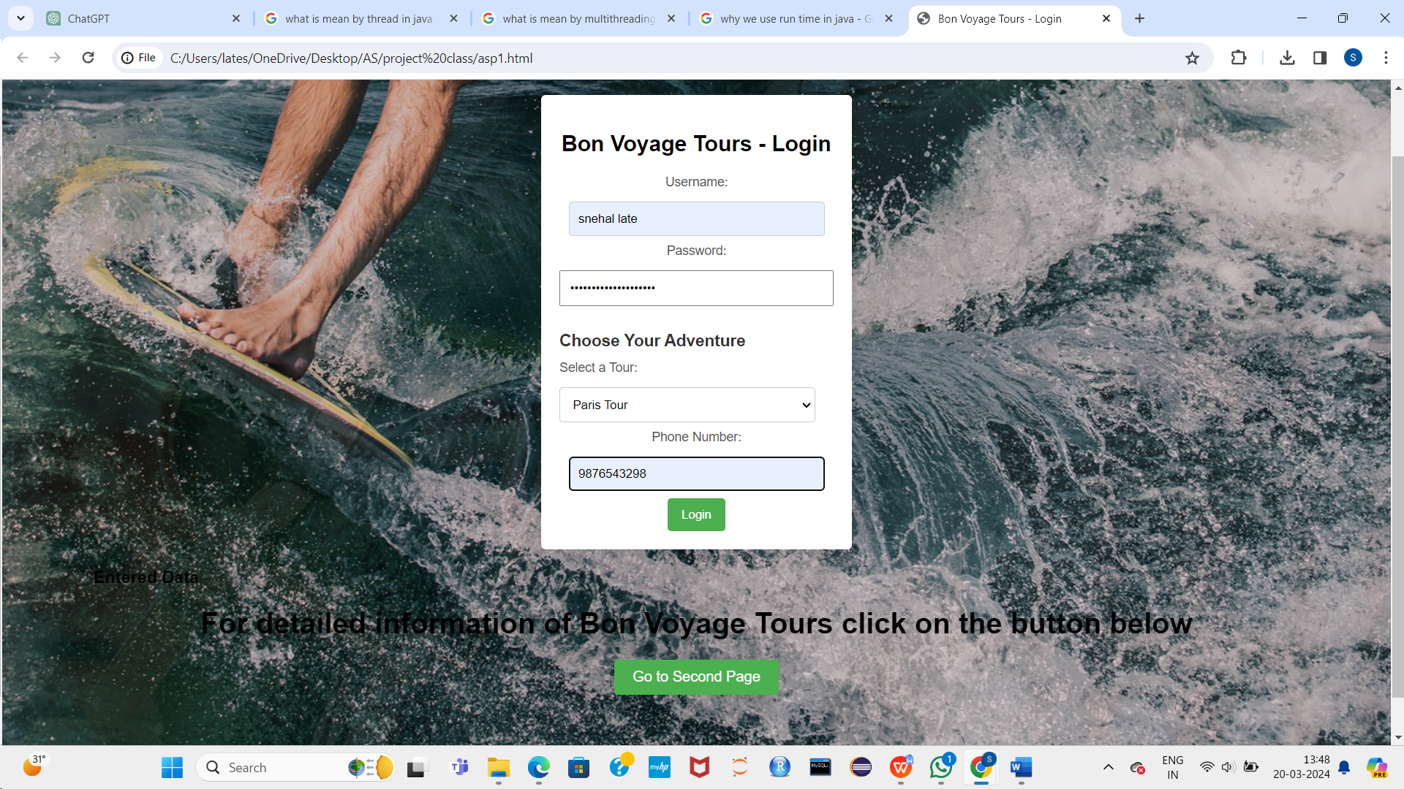

Encryption and Decryption Text:

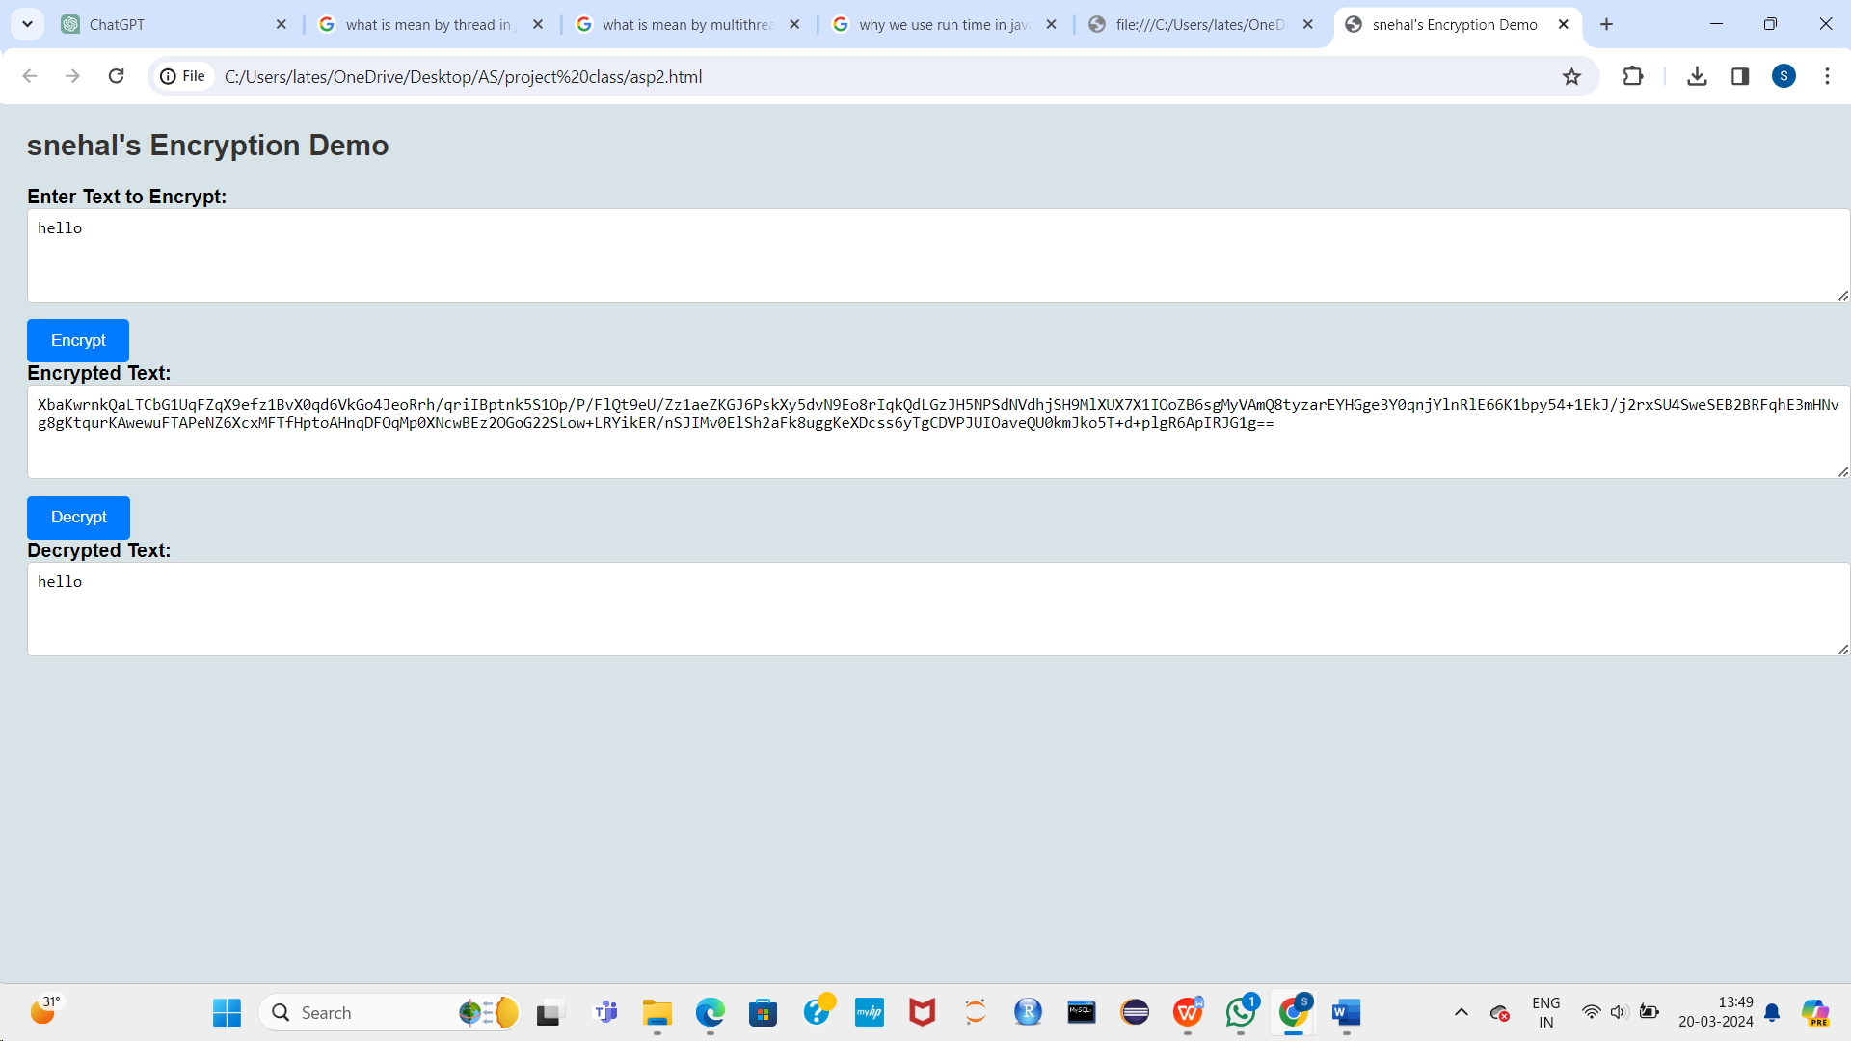

**Website Pages:**



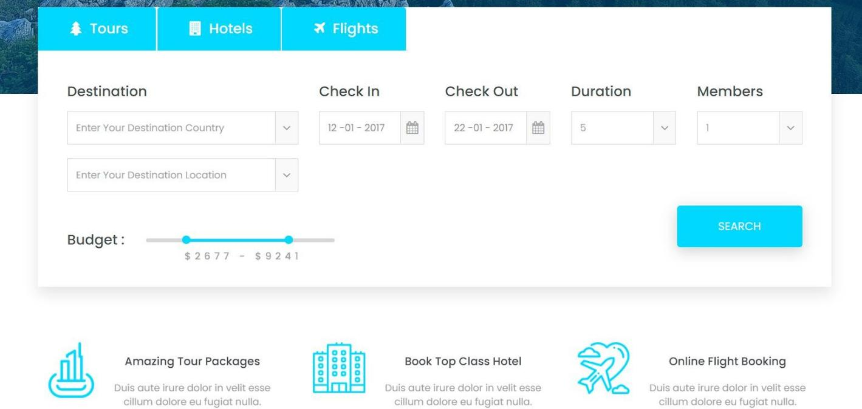

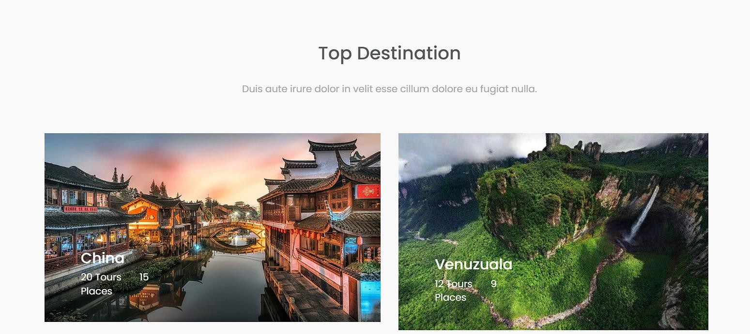



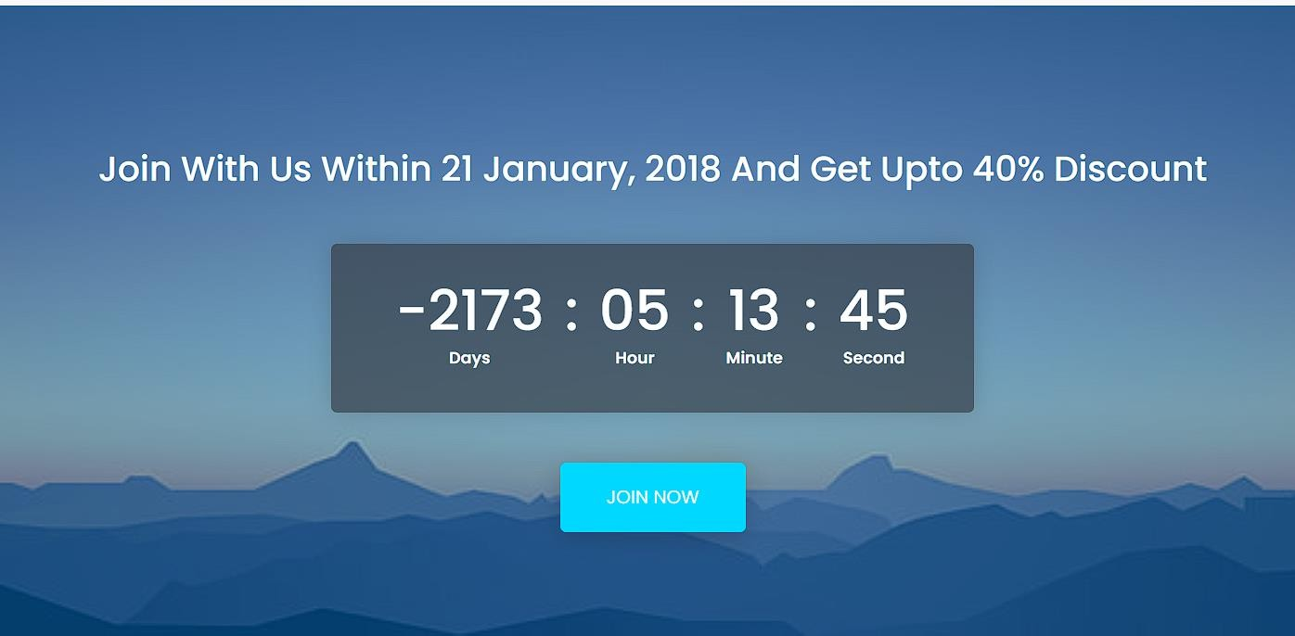

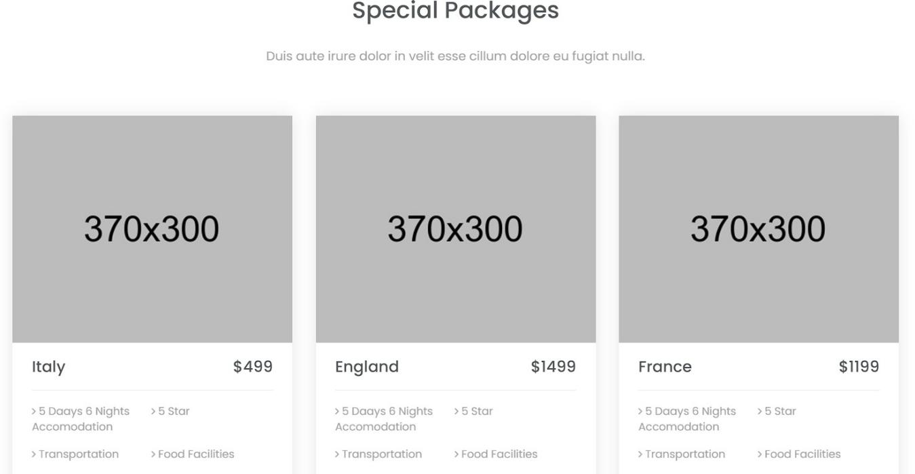







* 1. **Conclusion :**

In summary, the implementation of input security measures utilizing Public Key Infrastructure (PKI) at Bon Voyage Tours has significantly fortified data confidentiality and integrity within its communication system. Through systematic steps, including key pair generation, integration of PKI components, and adherence to compliance standards, the company has bolstered its defenses against cyber threats. By fostering a culture of security awareness and continuous improvement, Bon Voyage Tours ensures ongoing protection of sensitive information, instilling trust and confidence among stakeholders.

* 1. **References :**

1. **ChatGpt.ai**
2. **Blackbox.ai**
3. **https://[www.tutorialspoint.com/market/index.asp](http://www.tutorialspoint.com/market/index.asp)**
4. **<https://www.w3schools.com/html/>**